**Education System (Group Assignment)**

**Report Document**

|  |  |
| --- | --- |
| **Designed By -** | Neelesh Chandrakar, Yutong Gao, Manling Zhao |

Version History:-

|  |  |  |
| --- | --- | --- |
| **S.no.** | **Version** | **Changes** |
| 1 | 1.0 | Added the data source |
| 2 | 1.1 | Added the functionality details. |

**Table of Contents**

Introduction 3

Data of the Graduated Students 4

**Portal for Students** 5

Functionalities for Students: 6

**Top 5 Highest Paid Jobs.** 6

**Top 5 Companies** 7

**Top 5 Skills Sets** 7

**Top 10 Courses as per the Jobs** 8

**Portal for Administrators** 9

**Functionalities for Administrators:** 10

**Search students by name, major, gpa, salary or job title** 10

**Rank students by salaries or gpas** 11

**View student details** 12

**Compare two students** 13

Summary 14

# **Introduction**

This document is to introduce the changes that have been made for a school education system. A dashboard has been created and the functions that have been implemented are to compare students’ performances based on their grades and graduated students’ performances based on their salaries or job positions in a five-year period. And, from a student’s view where they want to continue their further studies based on the quality of the education provided by the schools. And investigate the top jobs available and what courses they need to take to achieve those jobs.

# Data of the Graduated Students

This data model will gather its data from sourcing social media platforms such as LinkedIn and the Northeastern Career Outcomes website where the students put on their own details.

<https://careeroutcomes.northeastern.edu/employment-status/>

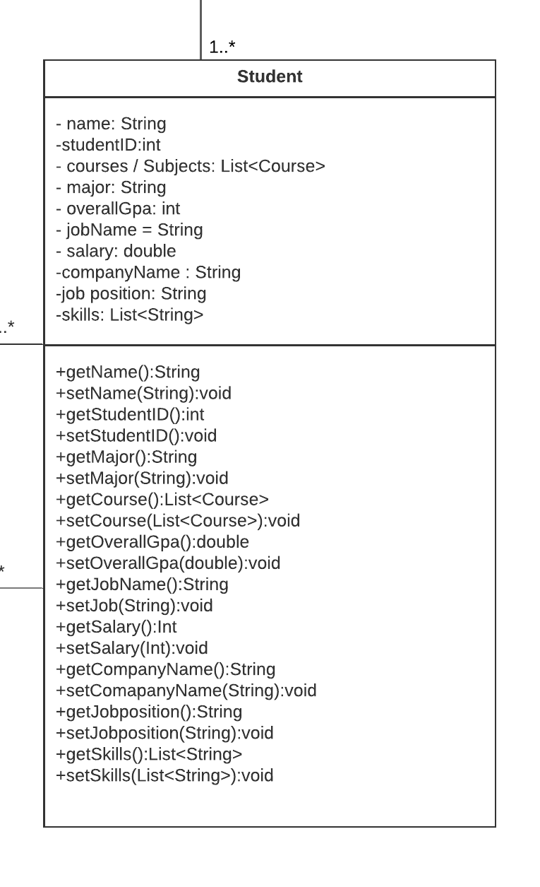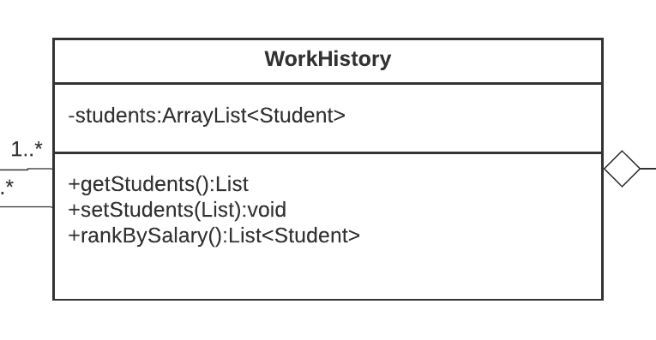

In this ‘Student’ class we are storing the details of the students and saving it in an Arraylist and later we will use this ‘WorkHistory’ class where we stored all the student details to fetch data for the viewers.

## **Portal for Students**

We have created a portal for students so that they can view what are the top five highest paid jobs students get after graduating from this school along with their courses and their instructors.

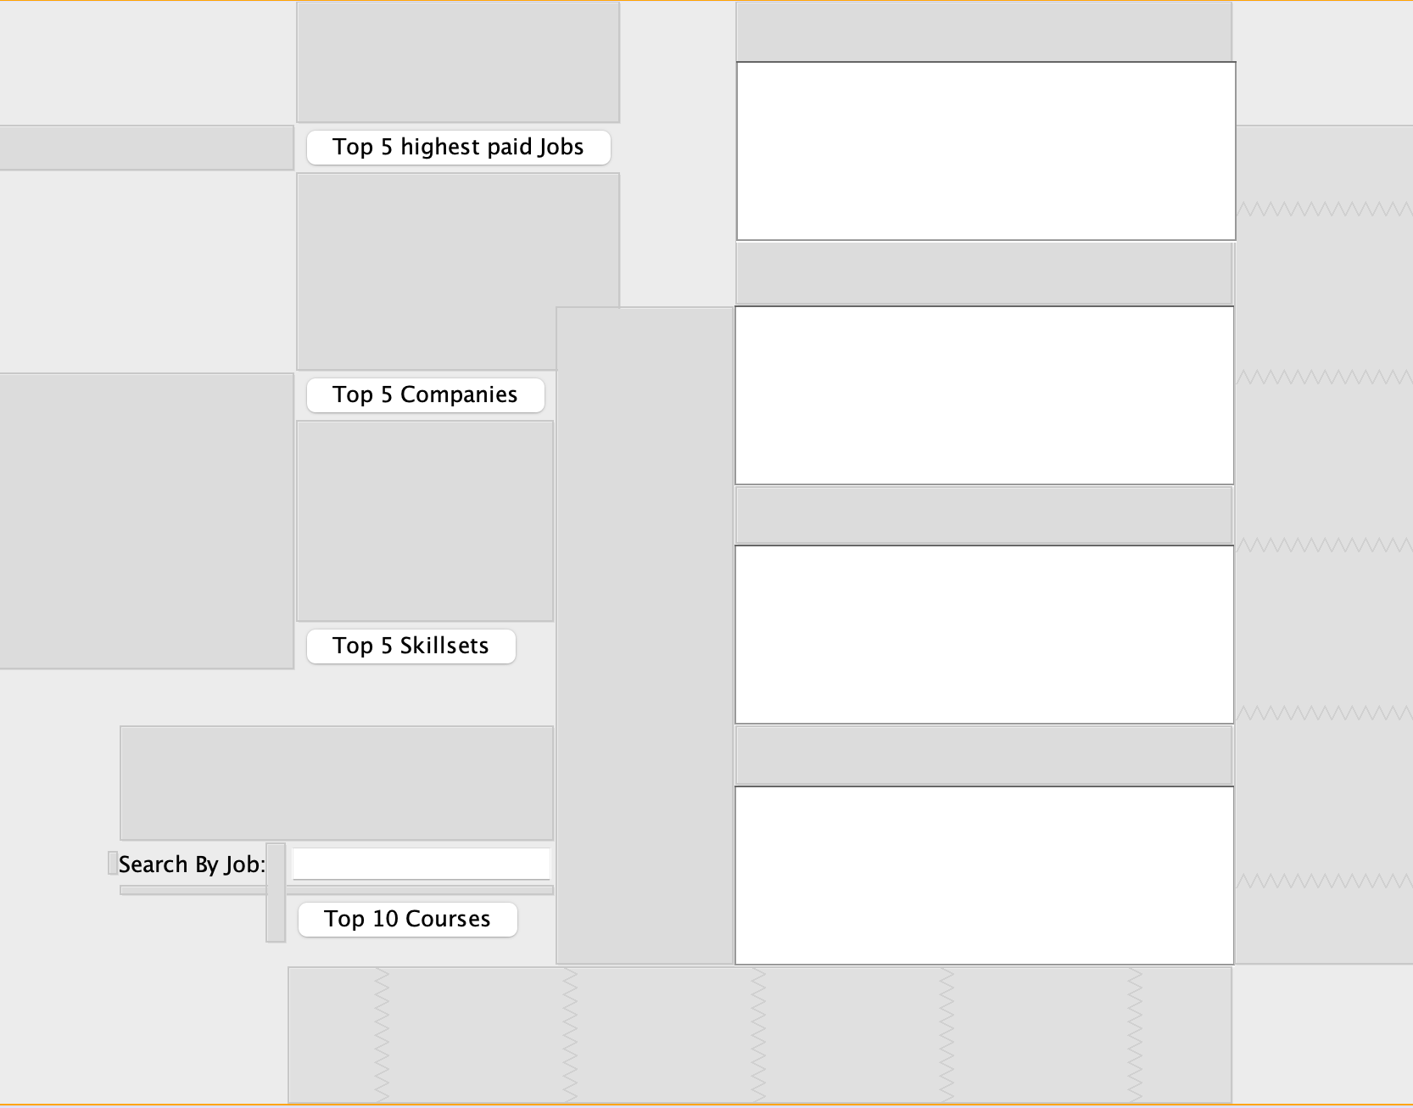

## Functionalities for Students:

1. **Top 5 Highest Paid Jobs**
2. **Top 5 Companies**
3. **Top 5 Skill Sets**
4. **Top 10 Courses as per the Jobs**

### **Top 5 Highest Paid Jobs.**

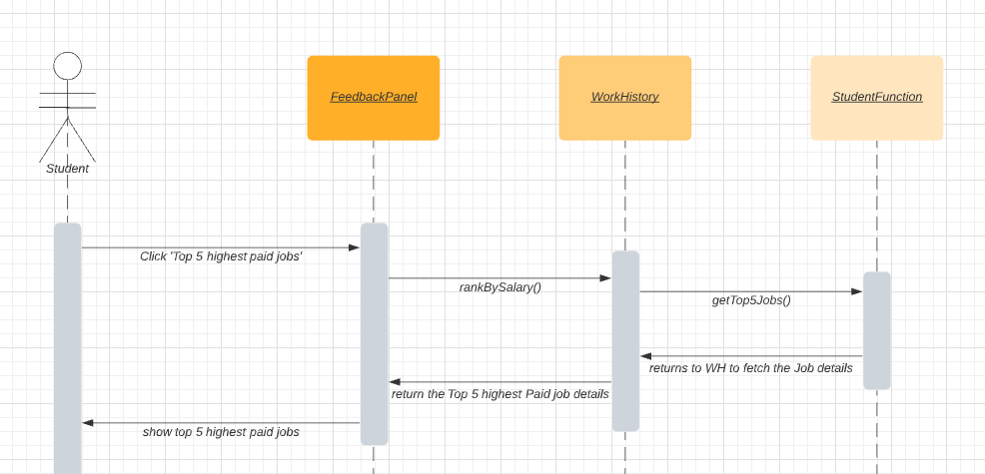

We have created a WorkHistory class where we have added a function named rankBySalary(). This function sorts the alumni as per their salaries in a descending order and stores it in an array list. We would then use the function named getTop5Jobs() in the StudentFunction class to fetch the first five elements from the sorted array list and return the results to the student user in the panel.

### **Top 5 Companies**

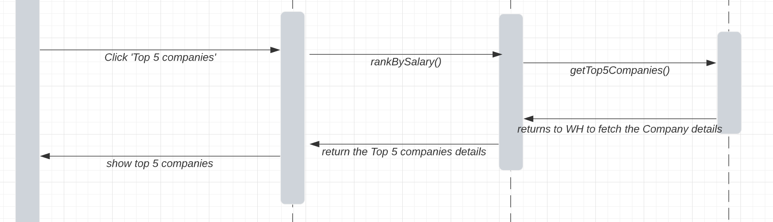

We have created a WorkHistory class where we have added a function named rankBySalary(). This function sorts the alumni as per their salaries in a descending order and stores it in an array list. We would then use the function named getTop5Companies() in the StudentFunction class to fetch the first five elements from the sorted array list and return the results to the student user in the panel.

### **Top 5 Skills Sets**

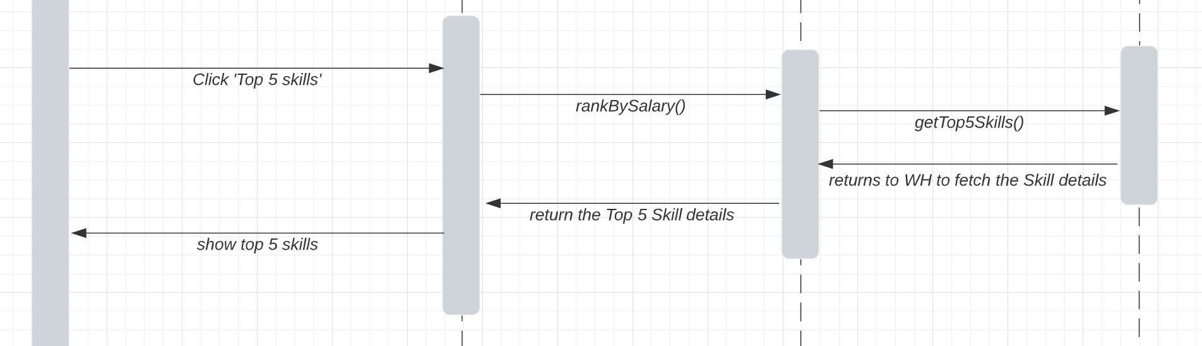

We have created a WorkHistory class where we have added a function named rankBySalary(). This function sorts the alumni as per their salaries in a descending order and stores it in an array list. We would then use the function named getTop5Skills() in the StudentFunction class to fetch the first five elements from the sorted array list and return the results to the student user in the panel.

### **Top 10 Courses as per the Jobs**

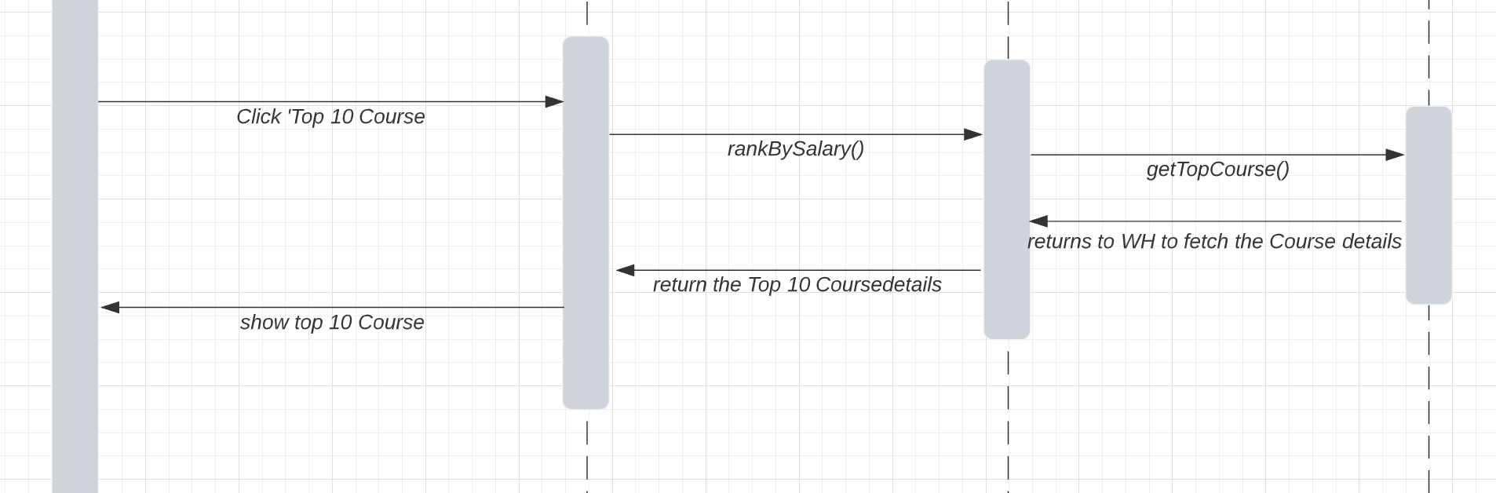

We have created a WorkHistory class where we have added a function named rankBySalary(). This function sorts the alumni as per their salaries in a descending order and stores it in an array list. We would then use the function named getTop10Couses() in the StudentFunction class to filter the details by the mentioned job and then fetch the first ten elements from the sorted array list and return the results to the student user in the panel.

# **Portal for Administrators**

We have also created a portal for administrators so that they can view details of all the students and update the students’ details. They can search students by their names, gpa, majors, job title or salary. They can also sort the students by their salary or gpa, and choose two students to compare.

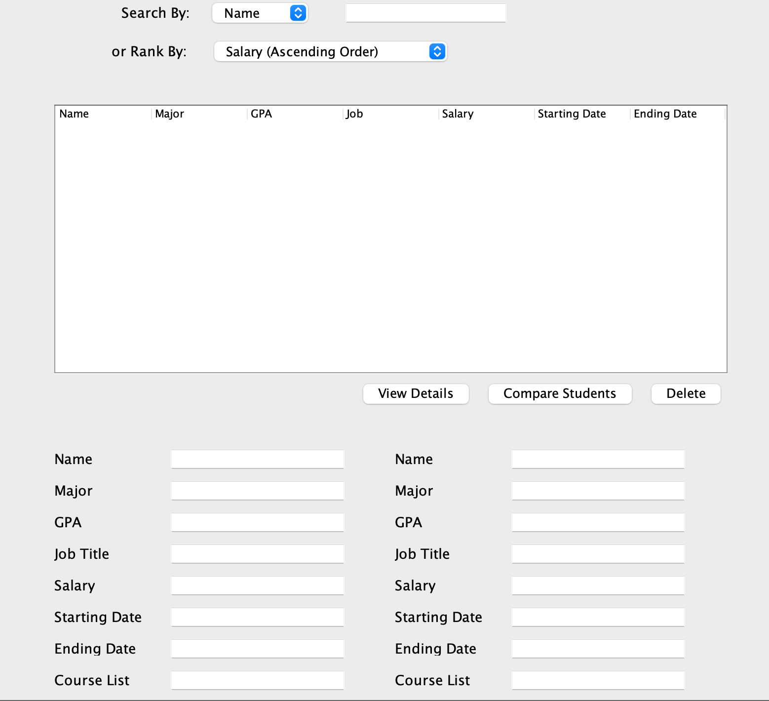

## **Functionalities for Administrators:**

### **Search students by name, major, gpa, salary or job title**

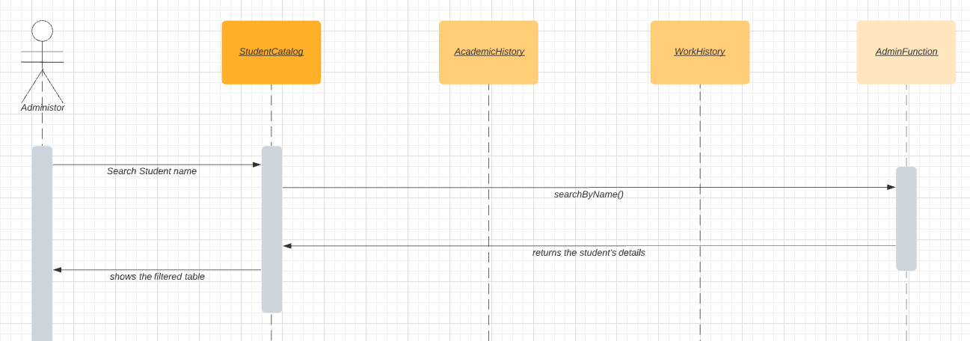

We have created an AdminFunction class where we have added a function named searchByName(). This function stores the text that has been entered in the text box and filters it in the array list where we have stored all the student’s details and then returns the result to the Admin’s table.

### **Rank students by salaries or GPAs**

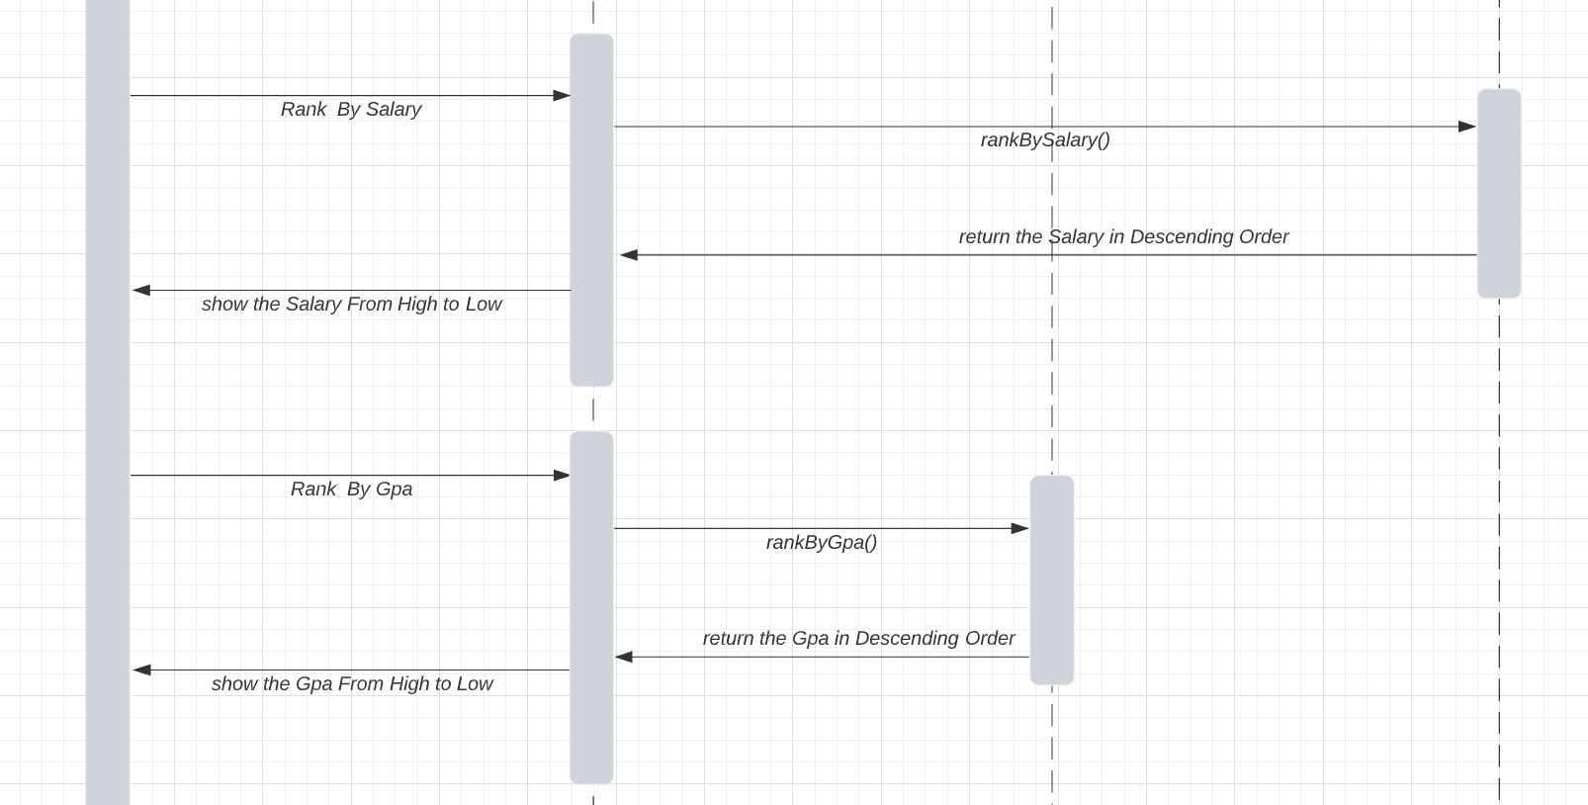

We used the method rankBySalary() which is in the WorkHistory class to rank the students by their salary. And then we show the students’ details in descending order on the Administrator panel. We used the method rankByGpa() in the AdminHistory class to rank the students by their gpa, and then we show the students’ details in descending order on the Administrator panel.

### **View student details**

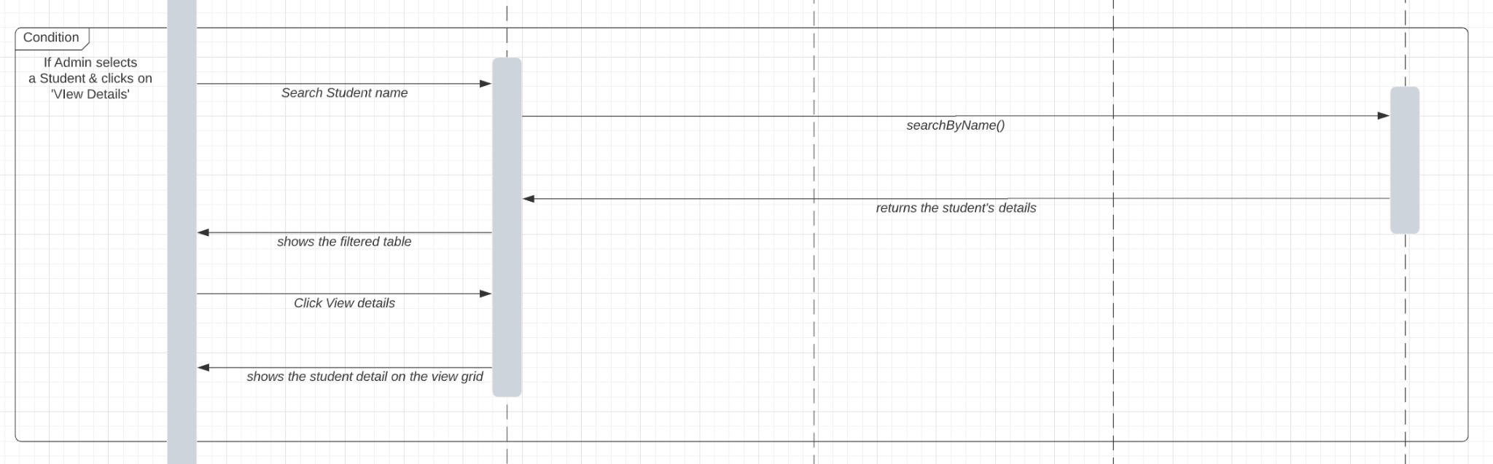

Whenever any details get fetched to the Admin’s table whether by searching or ranking. The Admin can select any student at the table and then view the details of that student in the below panel by clicking the ‘View Details’ button.

### **Compare two students**

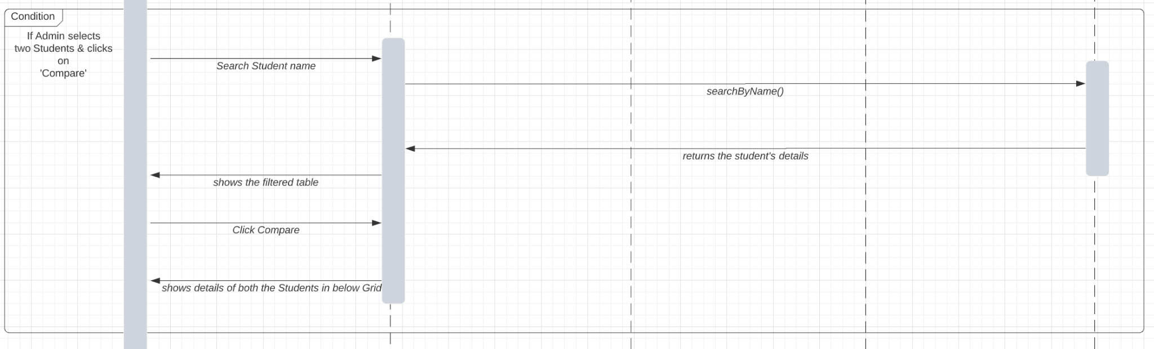

When there are students’ details showing in the table of the Administrator panel, the user can select two students who they want to compare by clicking the “compare” button.

# **Summary**

Our solution takes the University model and makes an improvement by creating the performance measurement to enable universities measure their quality of education by looking at how the graduates are doing in a five-year period. We have created a dashboard for both the faculty and students to check the career outcomes of the graduates. We rank the students by their salary and job positions, and list all the courses they have taken so that the user gets an idea on which courses are useful for a student’s career. It gives good suggestions to future students to choose relative courses based on their career interests.